|  |
| --- |
| SOUTHERN CROSS UNIVERSITY |

**ASSIGNMENT COVER SHEET**

For use with online submission of assignments

Please complete all of the following details and then make this sheet the **first page of each file of your assignment – do not send it as a separate document.**

Your assignments must be submitted as either **Word documents, text documents with .rtf extension or as .pdf documents**. If you wish tosubmit in any other file format please discuss this with your lecturer well before theassignment submission date.

|  |  |  |
| --- | --- | --- |
| Student Name: | **Yi Zhong** |  |
| Student ID No.: | **201700408059** |  |
| Unit Name: | **System Analysis and Design** |  |
| Unit Code: | **ISY00243** |  |
| Tutor’s name: | **Viettrung Luong** |  |
| Assignment No.: | **Assignment 1** |  |
| Assignment Title: | **Case Study: Grow Your Business** |  |
| Due date: | **6 weeks** |  |
| Date submitted: | **12/10/2018** |  |

Declaration:

*I have read and understand the Rules Relating to Awards (*[*Rule 3 Section 18 – Academic Misconduct Including Plagiarism*](http://policies.scu.edu.au/view.current.php?id=00140#s18)*) as contained in the SCU Policy Library. I understand the penalties that apply for plagiarism and agree to be bound by these rules. The work I am submitting electronically is entirely my own work.*

|  |  |
| --- | --- |
| Signed:  (please type your name) | Yi Zhong |
| Date: | 10/10/2018 |

Contents

SOUTHERN CROSS UNIVERSITY 1

Executive Summary 3

Introduction 3

Background 3

Organisation Chart 3

Business Function 4

System Vision Document 4

Problem Description 4

System Capabilities 4

Business Benefits 4

Project Planning 4

Gantt Chart 4

PERT Chart 4

Risk Analysis 4

Tangible Benefits 5

Intangible Benefits 5

Cost / Benefits Analysis 5

Feasibility 5

Use-case diagram

Brief Use Case description 5

Full Use Case Description 5

Activity Diagram 6

Recommendation 6

Conclusions 6

Appendices 6

Bibliography 6

# Executive Summary

# This report carefully designs and analyses the needs of the farm to “Grow Your Business” system. The report introduces the background and organization chart of "GYB", including and so on. In addition, it also lists the tangible benefits and tangible benefits that the new information system will bring, such as expanding the market size, increasing the rate of return, increasing the profit, etc., in addition to the feasibility and risk analysis of the project. At the same time, it also introduces a lot of use-case-related information and use-case diagrams, and summarizes some of the conclusions.

# Introduction

John returned to his family and converted the dairy farm into a farm because of the expanded commercial prospects of the farm. He also hired many assistants to help him manage the farm. But as the scope and quantity of production and the number of customers increased, John needed a more convenient way to help manage the farm business. The information system can design and solve these problems according to his needs, including product distribution, order and payment processing, and customer account processing.

# Background

John grew up on a farm. He loved farms very much, but unlike his parents, he used most of the land on the farm to grow vegetables. John was mainly responsible for farm production. Jane was mainly responsible for customer-related businesses. They all had their own assistants. These assistants were responsible for businesses such as Below:

Noel, Noeletta, Nick, Netta: Assist in farmer production.

Chris, Christina, Cathy, Charlie: Answer customer orders, report orders to Jane, assist in gardening activities at leisure, and other employees who specialize in gardening activities.

Mark, Masha, Dirk: Sorting and packing products and distribution.

Tim, Terry, Tina: Manipulating and maintaining agricultural machinery.

Sam, Samantha: Responsible for account status and payment method.

# Organisation Chart

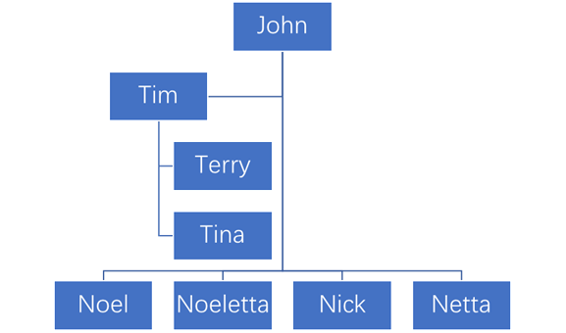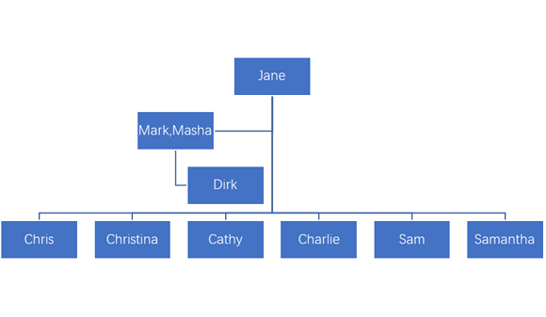

Business chart

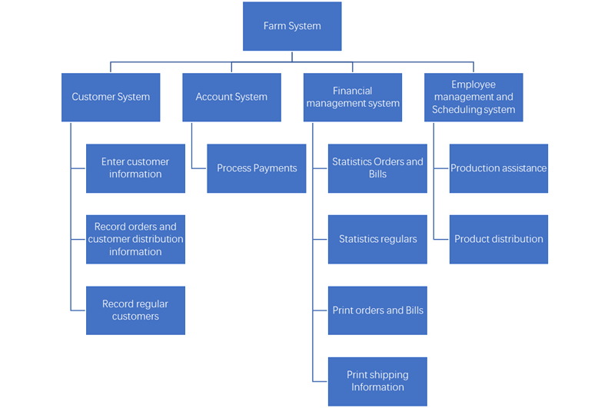

# 

# Business Function

|  |  |  |  |  |  |  |  |  |  |
| --- | --- | --- | --- | --- | --- | --- | --- | --- | --- |
|  | Function | | | | | | | | |
| Customer System | Enter customer information | Record orders and customer distribution information | Record regular customers |  |  |  |  |  |  |
| Account System | Process Payments |  |  |  |  |  |  |  |  |
| Financial management system | Statistics Orders and Bills | Statistics regulars | Print orders and Bills | Print shipping Information |  |  |  |  |  |
| Employee management and Scheduling system | Production assistance | Product distribution |  |  |  |  |  |  |  |

# 

# System Vision Document

## Problem Description

A new farm scheduling, sales and recording system，as farm products become more and more popular and customers become more and more, problems in farm transactions and management are highlighted, including complex order processing, inability to determine whether customers are paying, and farm traffic congestion. It is proposed to develop and deploy new systems to facilitate farm transactions and management.Customers can also communicate with farm employees more quickly through the system, which can also be deployed on the Web.

## System Capabilities

The new system should be capable of：

(1) Record orders, billing and customer payment information

(2) Record customer history purchase records and customer contact address and other distribution information.

(3) Dispatch employee distribution

(4) Print customer order and order related distribution information

(5) Dispatch employees to assist the farm production

## Business Benefits

(1) Optimize the customer purchase experience, so that customers do not have to come to the farm in person, but also the farm traffic conditions are relieved.

(2) Reduce the number of deliveries and labour costs, so that they can be in a day at a suitable time to unify the delivery of products.

(3) Support record of customer payment records, product booking and other ways to reduce the cost of payment time and hire payee, but also to avoid the customer on the order and bill the risk of non-payment.

(4) Record the customer's order history, make it convenient for the customer to buy next time, optimize the customer experience, and also make it convenient for the farm to count the popular agricultural products, so as to increase the profit of the farm.

(5) Record customer reservation, convenient to stock the farm in advance, reduce the loss of agricultural products.

# 

# Project Planning

## Gantt Chart

**Own design：**

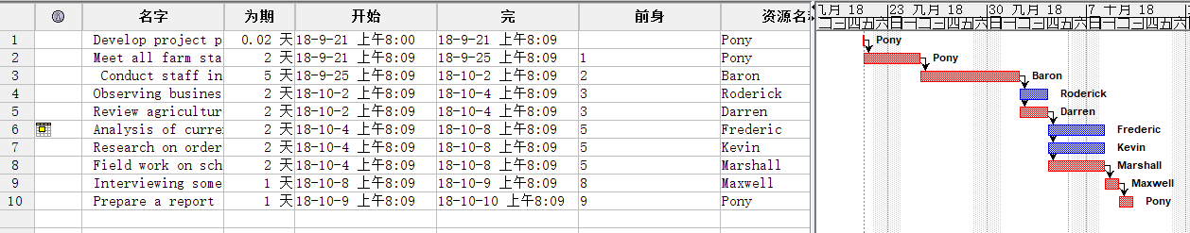

**Purchase from other companies：**

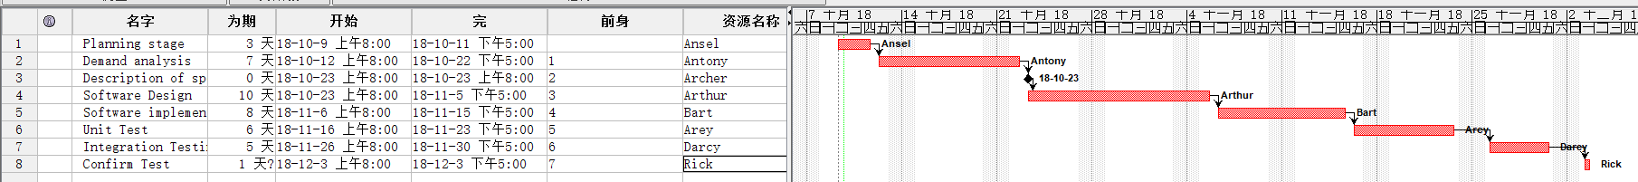

## 

## PERT Chart

**Own design：**

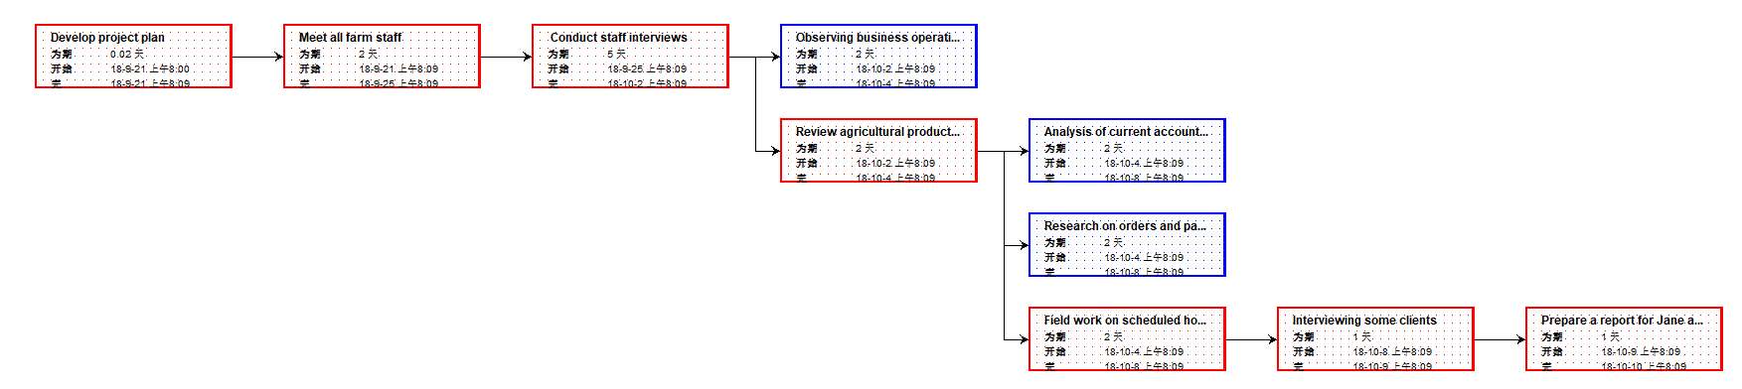

**Purchase from other companies：**



# 

# Risk Analysis

|  |  |  |  |  |
| --- | --- | --- | --- | --- |
| Risk description | Potential impact on project [high, medium, low] | Likelihood of occurrence [high, medium, low] | Difficulty of timely anticipation [hard, medium, easy] | Overall threat [high, medium, low] |
| System Vulnerabilities | low | low | medium | medium |
| Compliance Issues | medium | low | low | low |
| Employee resignation | low | medium | medium | high |
| Security Flaws | high | low | medium | high |
| Efficiency Weakness | low | low | low | low |
| Interface does not support system | medium | low | medium | medium |
| impact on User Operations | medium | medium | low | low |
| Hardware damage | high | medium | hard | high |
| Lack of experience in Project Manager | high | low | hard | high |
| Capital Chain Rupture | low | low | hard | high |

## Tangible Benefits

Get more profits,

Cost reduction,

Increase in market share,

Increase in number of customers.

## Intangible Benefits

Improving customer satisfaction,

Improving customer satisfaction,

Enhancing market competitiveness, raise productivity,

Improving employee morale.

# Cost / Benefits Analysis

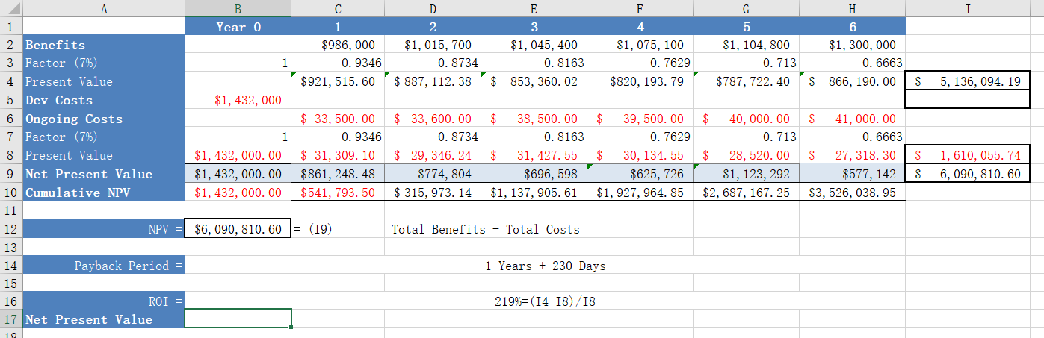

# Feasibility

# From the perspective of organizational feasibility, most farm employees may have no experience in using computer systems, lack of implementation experience or our organizational planning is not good, but this risk can be avoided, which can be solved through employee training and detailed and perfect planning of the project. In terms of technology and resource feasibility, technical support and necessary resources may be lacking, but in system development, we can solve it with more skilled technicians and more costs. As for the feasibility of the schedule plan, we have a very complete project schedule plan, which can be fully developed in our plan, so this aspect is also easy to achieve. In a word, this project is very feasible.

**Use case**

## *U*se-case diagram

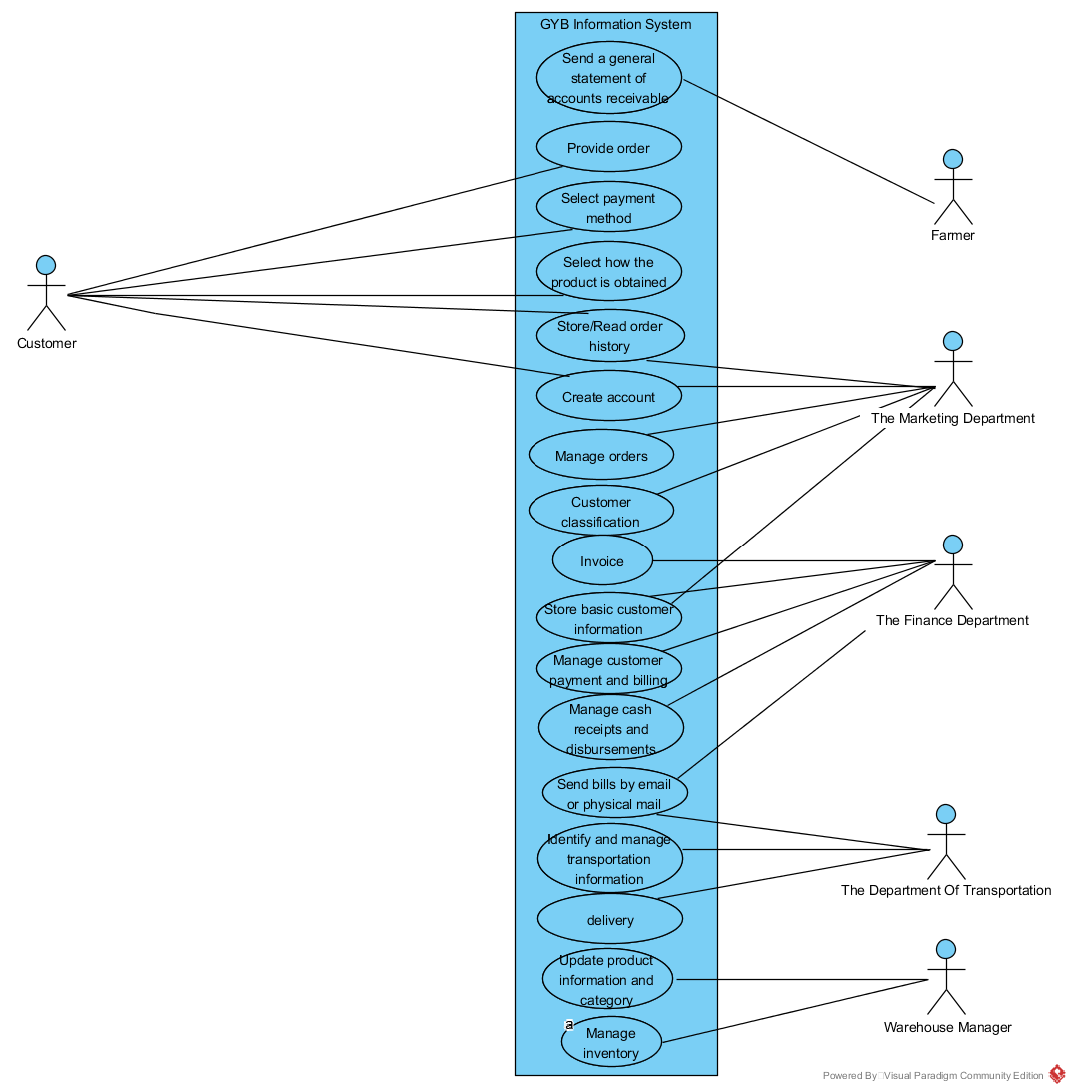

***Brief use-case descriptions***

|  |  |
| --- | --- |
| **Use case** | **Brief use case description** |
| Provide orders | The system displays the default order selection, and customers can provide their own order, or modify the default order through the checkbox interface, then the system stores the order and returns other system management information. |
| Delivery | Transportation personnel retrieve order details and delivery information and mark them as shipped, and mark which products are temporarily in short supply, and then deliver. |
| Identify and manage transportation information | The default display is sent to the customer's home address. The customer can enter the delivery address or come to the farm to fetch it. The system stores the distribution information and identifies the dangerous place. |
| Choose payment method | Customers choose the payment method, electronic online payment or cash on delivery or other, and the system recommends credit card online payment method, and the system keeps the payment record after the payment is successful. |

Full use-case description

|  |  |  |
| --- | --- | --- |
| **Use Case name** | Delivery | |
| **Scenario:** | Transport goods according to order and address information | |
| **Trigger event:** | The distribution personnel are notified by the system order or the person in charge of the Department that the goods are delivered. | |
| **Brief description:** | Transportation personnel retrieve order details and delivery information and mark them as shipped, and mark which products are temporarily in short supply, and then deliver. | |
| **Actor:** | Transport personnel | |
| **Related use cases:** | Related to " Identify and manage transportation information " | |
| **Stakeholders:** | The sales department  The department of transportation  Warehouse manager | |
| **Preconditions:** | Orders must be given;  Address and customer information must be ensured correct;  The commodity must exist; | |
| **Postconditions:** | Mark successful appointments as "reminders"；Mark unsuccessful appointments as "reminders unfinished". | |
| **Flow of activities:** | **Actor** | **System** |
| 1. The delivery personnel receive the order delivery information. 2. Transport personnel check address information and prepare distribution. 3. Mark the delivered and non-deliverable products separately | 1.1 System inquiry address and related delivery information  2.1 System notifies farm deliveries nearest to the delivery address.  3.1 System updates commodity types and inventory.  3.2 The system updates the delivery information in real time and notifies the delivery manager when the abnormal delivery occurs. |
| **Exception condition:** | 2.1 If the delivery crew can not deliver to the designated address in case of abnormal situation, the other delivery personnel must be informed.  3.1 If the damaged goods in the warehouse need to manually update the relevant commodity information. | |

***Activity diagram***

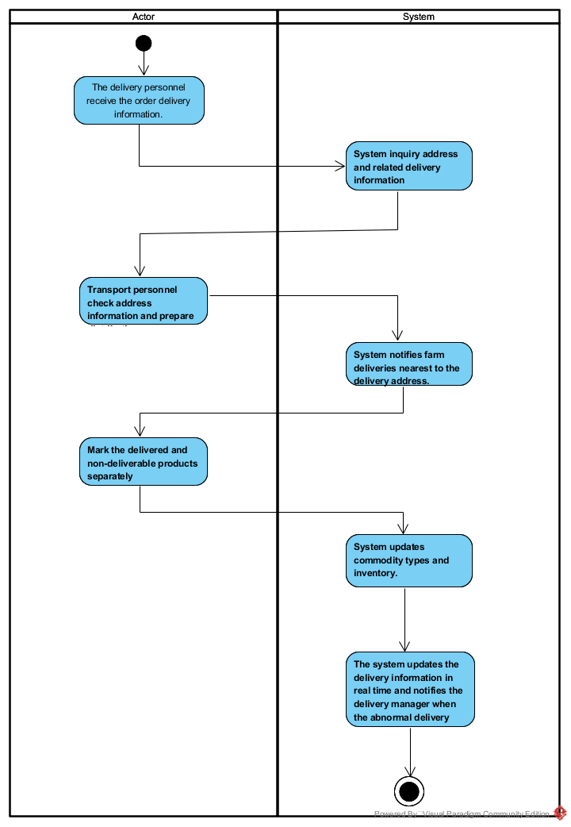

# Recommendation

Through the analysis of the new information system, we know that although our new system has met many basic requirements, but for the later software testing, our planning is not perfect. Therefore, we recommend another company's Gantt and pert charts, their Gantt and pert charts for this part of the more detailed planning and supplementary description, while the project expression part is more concise, more conducive to the implementation of the project and the acceleration of progress.

# Conclusions

The development and study of this project system made me gain a lot. From a personal point of view, blindly stacking code is not very helpful to the development of the project, but on the one hand to communicate with the team immediately, especially business-related module leaders, development progress and development function point unification, timely docking to find problems. From the team point of view, reasonable division of labor, appropriate project organization and process planning are the key to a successful project. A project development can not be controlled by a single individual ability. It is very important to carry out reasonable development process planning according to different project types. In the process of development, progress and quality are also important.

# 

# Appendices

|  |
| --- |
| Discussion and interview Agenda |
| **Setting**  Objective of interview  *Determining new requirements for the system*  Date, Time, and Location  *October. 5, 2018, at 9:00 a.m. in John’s office*  User Participants (names and titles/positions)  *William McDougal, vice president of marketing and sales, and several of his staff*  Project Team Participants  *Nick and Sam* |
| **Interview/Discussion** |
| *1. Who is the main object of using the system?*  *2. Do you know the basic operation procedures and functions of the new sales system?* *Is it convenient to use?*  *3.* *What is the range of vegetables and the availability in a year?*  *4.Does the report generated by the information system need to be formatted? Or do you need to save it?*  *5.* *Which way do you prefer to input information system? Direct input or scan input?*  *6. How often do you expect to deliver the goods?* *How do you want to promote products? E-mail? Telephone or something else?*  *7.* *Are there any restrictions on the number of orders placed by users?*  *8. What aspects of customer cancellation may be caused by farm failures?* |
| **Follow-Up** |
| Important decisions or answers to questions  *See attached write-up on commission policies*  Date and time of next meeting or follow-up session  *October 10, 2018, at 9:0O a.m.* |

# Bibliography

Buy from other company’s grant chart: <https://image.baidu.com/search/detail?ct=503316480&z=0&ipn=d&word=%E7%94%98%E7%89%B9%E5%9B%BE&step_word=&hs=2&pn=9&spn=0&di=197175607200&pi=0&rn=1&tn=baiduimagedetail&is=0%2C0&istype=0&ie=utf-8&oe=utf-8&in=&cl=2&lm=-1&st=undefined&cs=374743768%2C3062809681&os=2395437186%2C1293979988&simid=4204950639%2C605532383&adpicid=0&lpn=0&ln=1897&fr=&fmq=1539068059674_R&fm=&ic=undefined&s=undefined&se=&sme=&tab=0&width=undefined&height=undefined&face=undefined&ist=&jit=&cg=&bdtype=0&oriquery=&objurl=http%3A%2F%2Fg.hiphotos.baidu.com%2Fzhidao%2Fpic%2Fitem%2Fa6efce1b9d16fdfaf95ec7cbb18f8c5494ee7be0.jpg&fromurl=ippr_z2C%24qAzdH3FAzdH3Fzit1w5_z%26e3Bkwt17_z%26e3Bv54AzdH3Fq7jfpt5gAzdH3Fnldc0dmalnb9d9blmc_z%26e3Bip4s&gsm=0&rpstart=0&rpnum=0&islist=&querylist>=

Book: Introduction to Systems Analysis and Design An Agile, Iterative Approach Six Edition.